Technical Story Card

Revision History
Version No. | Date | Prepared by / Modified by | Significant Changes
1 | 15 Feb 2022 | Prasad D | Draft version
2 | 15 Feb 2022 | Iswari Sonkusale | Draft Version
3 | 15 Feb 2022 | Aniket Chafle | Draft Version
4 | 15 Feb 2022 | Ponni P | Draft Version

Glossary
Abbreviation | Description
BSC | Business Story Card
TSC | Technical Story Card

Table of Contents
1 Introduction 3
2 Scope of Change 3
3 List of impacted modules 3
4 Design and Detailed technical updates 4
4.1 Process model 4
4.1.1 Use case Model 4
4.1.2 Sequence diagram 4
4.2 Proposed user Interface design 4
4.3 Database design changes 4
4.4 Refactoring related changes 4
4.5 Construction strategy and re-use 4
5 Details of Alternative Design Approach 4
6 Other Technical changes 5
6.1 Automation tasks / changes 5
6.2 CI / Build relates tasks / changes 5
6.3 Non-functional related changes 5
7 Additional details 5
7.1 Open Questions / clarifications / Assumptions 5
7.2 Additional notes to technical team 5
8 References 5

Introduction
College Voting System would have Candidate registration, Admin login, Student login, User poll. Admin login which will be handled by College Administration. Candidate Login which will be handled by Candidate, Voters will get Unique ID and Password, Using which they can vote for a Candidate only once per Election. The project is beneficial for Election Commission, Voters as they can get to know the candidate background and choose wisely, and even for Candidate.

The software system allows the Candidate to login in to their profiles and upload all their details onto the system. The admin can check each Candidate details and verify the documents, only after verifying Candidate’s ID and Password will be generated, and can remove faulty accounts. The software system allows Voters to view a list of Candidates. The admin has overall rights over the system and can moderate and delete any details not pertaining to College Election Rules.

Modules:
- Admin Login
- Student Registration Form
- Candidate Registration form
- Student Login
- User Poll

Scope of Change
Change will not be entertained and whatever specifications mentioned in this document is final.

List of impacted modules
All the functional modules will be created from scratch.

Design and Detailed technical updates

Process model

Use case Model
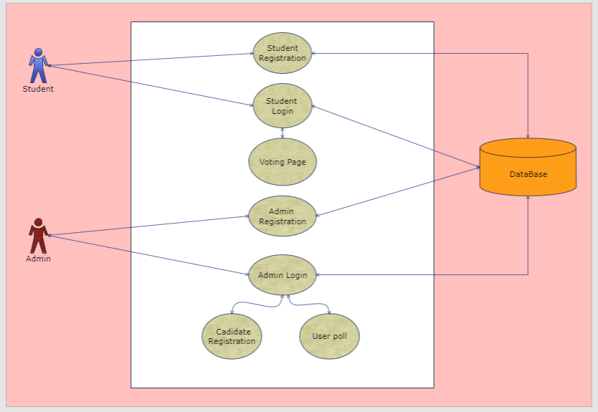

Brief Description | Student Registration
Basic Flow | This use case describes how a student register in to the system  - The student has to register himself into the system.  - After the successful registration, student will get a success message.  - The following information is required during registration.  - Name  - Roll Number  - Email Id  - Mobile Number  - Department  - Year Of Passing
Alternate Flow | - The system will validate the information provided. If any invalid data is found, the input form will be redirected with error message.
Validation | - Name is required and minimum 3 characters and max 30 characters.  - Roll number can be alphanumeric.  - Department can be alphanumeric.  - The Email should be valid.
Pre-Conditions | User should have network access and Browser with latest updates.
Post-Conditions | Success message should be shown after the registration.

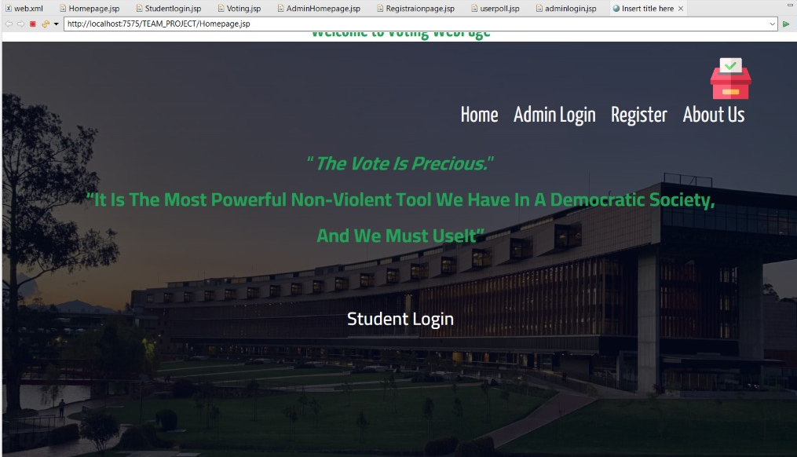

Brief Description | Candidate Registration
Basic Flow | This use case describes how a candidate register in to the system  - The admin has to register candidate’s information into the system.  - After the successful registration, success message has to popup.  - The following information is required during registration.  - Candidate Name  - Department  - Email  - Mobile Number  - Party Name
Alternate Flow | - The system will validate the information provided. If any invalid data is found, the input form will be redirected with error message.
Validation | - Name is required and minimum 3 characters and max 30 characters.  - Department can be alphanumeric.  - Party Name is required and minimum 3 characters and max 30 characters.  - The Email should be valid.
Pre-Conditions | User should have network access and Browser with latest updates.
Post-Conditions | Success message should be shown.
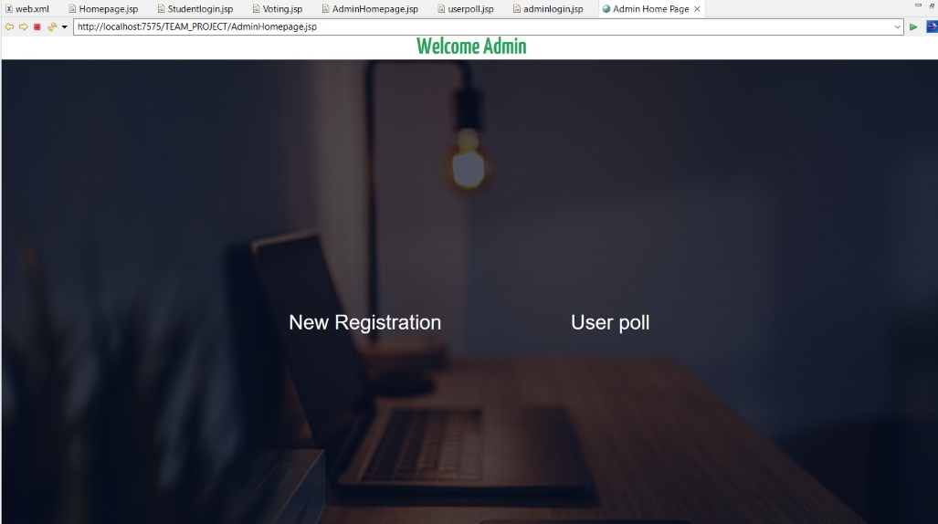

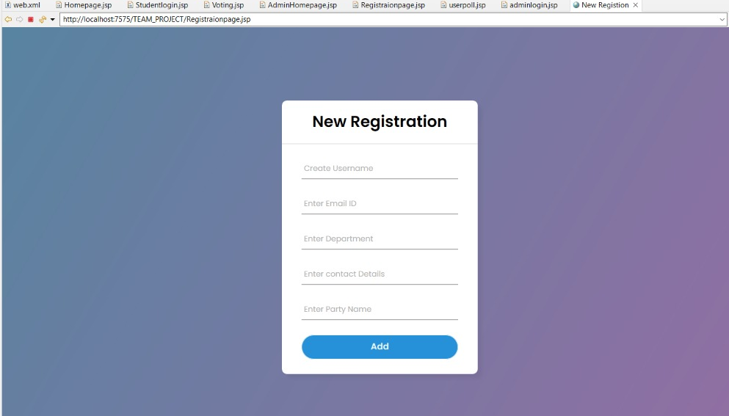

Brief Description | Student Login
Basic Flow | This use case describes how a student log-in in to the system  - The student has to register himself into the system.  - After the successful login, student will be taken to the appropriate login page.  - The following information is required to login.  - username  - password
Alternate Flow | - The system will validate the credentials provided. If credentials are invalid, login form will be redirected again with error message.
Validation | - Valid username  - Valid password
Pre-Conditions | User should have network access and Browser with latest updates.
Post-Conditions | Login page has to be displayed and redirected to voting page.

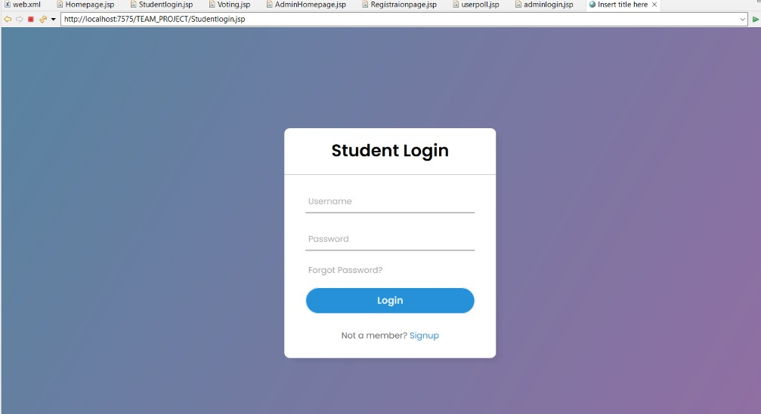

Brief Description | Admin Login
Basic Flow | This use case describes how an admin log-in in to the system  - The admin has to login into the system.  - The following information is required during login.  - Username  - Password
Alternate Flow | - The system will validate the information provided. If any invalid data is found, the input form will be redirected with error message.
Validation | - Valid Username  - Valid Password
Pre-Conditions | User should have network access and Browser with latest updates.
Post-Conditions | Login page has to be displayed and redirected to userpoll.

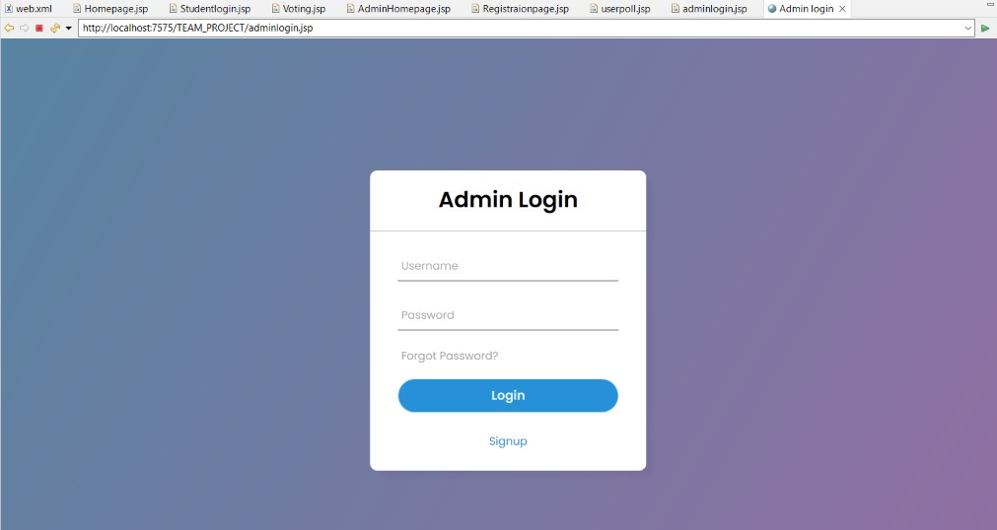

Brief Description | User Poll
Basic Flow | This use case describes how an admin can view the status of the voting results.  - The admin has to login into the system.  - The following information has to be displayed.  - Voting result in percentage
Alternate Flow | Not Applicable
Validation | Not Applicable
Pre-Conditions | Admin should have already logged into the system.
Post-Conditions | Not Applicable

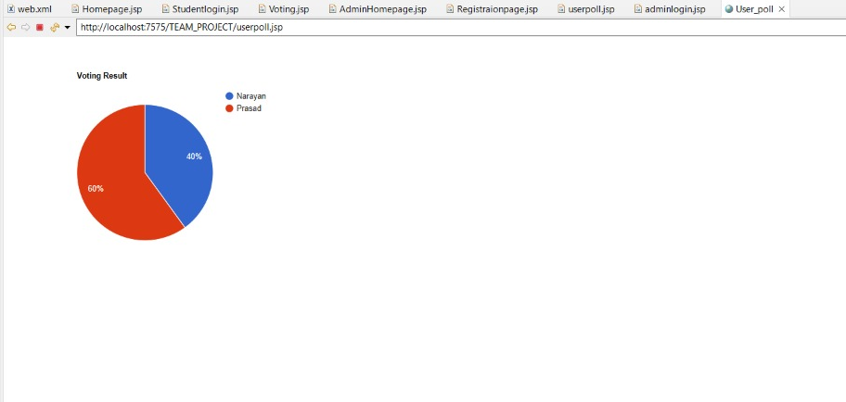

Architecture Diagram

Layer
Logical View
Technology/ Framework

UI Components
Presentation Layer
HTML/ CSS/ JavaScript
Export (pdf)
Validations
Resources

Report

Web-Server Classes
Java 1.8/ Spring MVC
Application/ Business Layer
Configuration
Controllers

Service
REST Controllers

Entity/ Model Classes

Data Access Layer
Repository classes
Spring Boot

php
Database

Presentation Layer:
This layer consists of all UI components.
- Export component: The plug-in is used to export the reports in pdf format. It helps to reduce the workload on the web/ application server.
- Validation component: All basic level data validations should be done at UI level.
- Report component: All reports to be generated to the user, will be processed and generated at the browser end.
- Resources: All HTML/CSS/ images, which are required for the page design.
Application Layer:
This layer comprises of all server and business classes.
- Configuration settings (XML or Class based) will define the application and server configuration.
- Spring Controllers defines the server classes, which are required to process the incoming http requests.
- Service classes are required to perform the required business services.
- REST Controllers to process the HTTP AJAX requests.
- Model classes are used the define the functions of the entities present in the system.
Data Layer:
Data layer is implemented through spring boot. It will contain the repository classes, which provides interface to the table.

Class Diagram

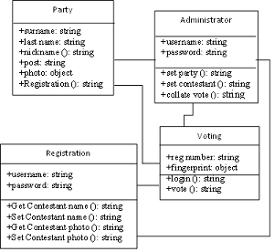

Sequence diagram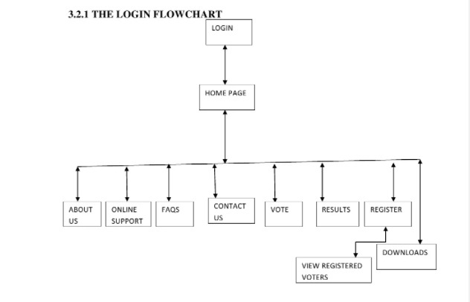

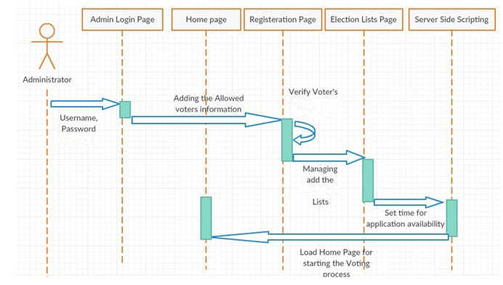

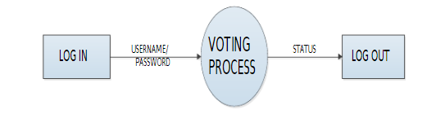

References
Amankona, E. and Paatey, E. (2009). Online Voting Systems. Graduation Project, Wisconsin International University College, Ghana. Gordon, T. (1998). On Voting. Kyklocls International Review for Social Sciences, Vol 52, No 1, pp 126–128.

Grossman, W. M. (2004). Ballot Breakdown. Scientific American, Vol 290, No 2, pp 16-18. Idike A. N. (2014). Democracy and the Electoral Process in Nigeria: Problems and Prospects of the E-Voting Option, Asian Journal of Humanities and Social Sciences (AJHSS), Vol. 2, Issue 2, pp 133-141. Available online at www.ajhss.org [Accessed: 10 Apr 2015].

